**COMM 4240**

**Project Milestone 2 (Part 2)**

**Team EatNomz (Bill, Carmel, Conrad, Jairus)**

**2/17/2016**

**Part 2a: Survey Design - Questions**

**Functional design questions**

Please rate the website with respect to the following functional design element:

1. How quickly pages load

Not quick at all Very quick

1 - 2 - 3 - 4 - 5 - 6 - 7 - 8 - 9 - 10

1. Ease of navigating and browsing

Not easy at all Very easy

1 - 2 - 3 - 4 - 5 - 6 - 7 - 8 - 9 - 10

1. How interactive is the website?

Not interactive at all Very interactive

1 - 2 - 3 - 4 - 5 - 6 - 7 - 8 - 9 - 10

1. Ease of finding the product you were looking for

Not easy at all Very easy

1 - 2 - 3 - 4 - 5 - 6 - 7 - 8 - 9 - 10

1. Ease of making a purchase

Not easy at all Very easy

1 - 2 - 3 - 4 - 5 - 6 - 7 - 8 - 9 - 10

1. Overall effectiveness of the website’s functionality

Not effective at all Very effective

1 - 2 - 3 - 4 - 5 - 6 - 7 - 8 - 9 - 10

**Visual design questions**

Please rate the website based on the following visual design element:

1. Helpfulness of the website’s layout

Not helpful at all Very helpful

1 - 2 - 3 - 4 - 5 - 6 - 7 - 8 - 9 - 10

1. Helpfulness of the website’s graphics

Not helpful at all Very helpful

1 - 2 - 3 - 4 - 5 - 6 - 7 - 8 - 9 - 10

1. Helpfulness of the product images provided

Not helpful at all Very helpful

1 - 2 - 3 - 4 - 5 - 6 - 7 - 8 - 9 - 10

1. Appealing nature of the website’s font styles

Not appealing at all Very appealing

1 - 2 - 3 - 4 - 5 - 6 - 7 - 8 - 9 - 10

1. Amount of content per page

Too much content Just the right amount of content

1 - 2 - 3 - 4 - 5 - 6 - 7 - 8 - 9 - 10

1. Overall satisfaction of the website’s visual appearance

Not satisfying at all Very satisfying

1 - 2 - 3 - 4 - 5 - 6 - 7 - 8 - 9 - 10

**Information design questions**

Please rate the website based on the following information design element:

1. Usefulness of information on how the business works

Not useful at all Very useful

1 - 2 - 3 - 4 - 5 - 6 - 7 - 8 - 9 - 10

1. Usefulness of product descriptions provided

Not useful at all Very useful

1 - 2 - 3 - 4 - 5 - 6 - 7 - 8 - 9 - 10

1. Usefulness of product customer reviews provided

Not useful at all Very useful

1 - 2 - 3 - 4 - 5 - 6 - 7 - 8 - 9 - 10

1. Ease of reading product information (description and reviews)

Not easy at all Very easy

1 - 2 - 3 - 4 - 5 - 6 - 7 - 8 - 9 - 10

1. Usefulness of contact information provided

Not useful at all Very useful

1 - 2 - 3 - 4 - 5 - 6 - 7 - 8 - 9 - 10

1. Overall usefulness of information provided

Not useful at all Very useful

1 - 2 - 3 - 4 - 5 - 6 - 7 - 8 - 9 - 10

**Trustworthiness and Satisfaction questions**

Please rate the website based to the following:

1. Overall trustworthiness of the website

Not trustworthy at all Very trustworthy

1 - 2 - 3 - 4 - 5 - 6 - 7 - 8 - 9 - 10

1. Overall level of satisfaction with the website

Not satisfied at all Very satisfied

1 - 2 - 3 - 4 - 5 - 6 - 7 - 8 - 9 - 10

**Demographic questions**

1. Please indicate your gender:
   1. Male (1)
   2. Female (2)
   3. Other / Prefer not to disclose (3)
2. What is your age range?
   1. < 18 (1)
   2. 18-24 (2)
   3. 25-34 (3)
   4. 35-44 (4)
   5. 45-54 (5)
   6. 55-64 (6)
   7. 65+ (7)
   8. Prefer not to disclose (8)
3. What is your income level?
4. < $40,000 (1)
5. $40,000 - 60,000 (2)
6. $60,000 - 75,000 (3)
7. $75,000 - 100,000 (4)
8. > $100,000 (5)
9. Prefer not to disclose (6)
10. Ethnicity origin (or Race):
11. White (1)
12. Hispanic or Latino (2)
13. Black or African American (3)
14. Asian or Pacific Islander (4)
15. Native American or American Indian (5)
16. Other (6)
17. Prefer not to disclose (7)

**Additional questions**

1. How often do you visit the website?
2. Daily (1)
3. 2-3 times a week (2)
4. Once a week (3)
5. 2-3 times a month (4)
6. Once a month (5)
7. Less than once a month (6)
8. Almost never (7)
9. Please rate the website based on the following:

Likelihood of placing an order on the website

Not likely at all Very likely

1 - 2 - 3 - 4 - 5 - 6 - 7 - 8 - 9 - 10

1. Please rate the website based on the following:

Likelihood of recommending Nomz to your friends

Not likely at all Very likely

1 - 2 - 3 - 4 - 5 - 6 - 7 - 8 - 9 - 10

1. Please rate the website based on the following:

Level of success in completing your objectives of visiting the website

Not successful at all Very successful

1 - 2 - 3 - 4 - 5 - 6 - 7 - 8 - 9 - 10

1. Please leave any additional comments below:

**Part 2b: Survey Development – Building the Instrument**

View the Qualtrics survey here:

<https://drive.google.com/file/d/0B_3oKnHU3HFWSEFXOXBaSDAwS2M/view?usp=sharing>

Some previews: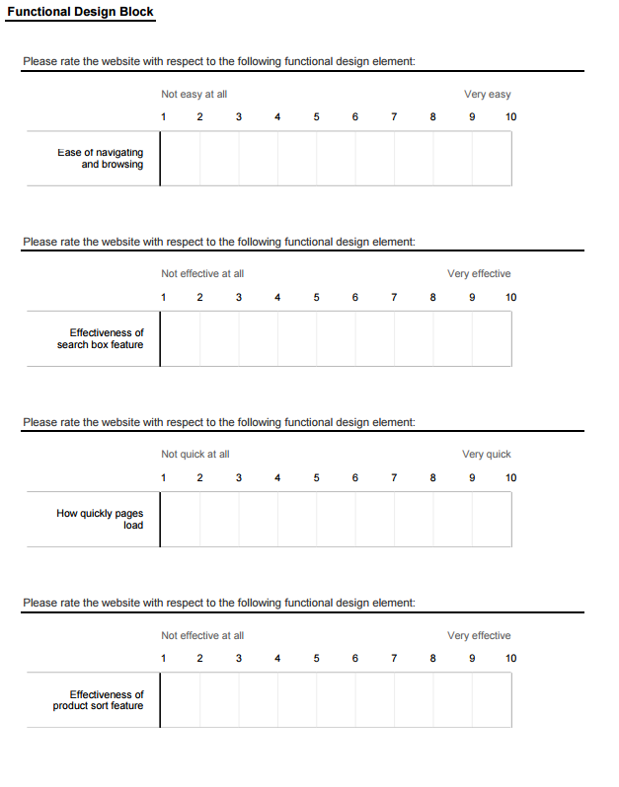

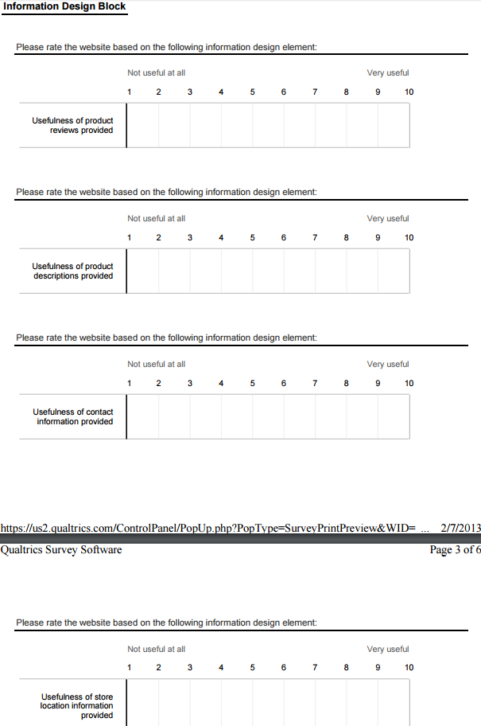

**Part 2c: Identifying Survey Population**

The survey will be distributed to both the founder’s personal connections in New York and current customers. The client will distribute the survey personally to a listserv of current customers, a population of 241, and to as much personal connection as needed. A previous survey distributed by the firm in September of 2015 received over 150 responses. Past open rate and other information are not available for the survey.

TODO: potentially reah out to student population → separate URL

can do an analysis where you merge